FACULTY PROFILE

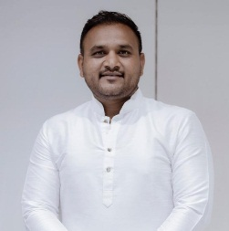

Name : Mr. Jadhav Gourav Arun

Qualification : B.A., M.P.Ed, SET, Ph.D (Appear)

Department : Physical Education and Sports

Designation : Director of Physical Education

Email :gouravjadhav.009 @gmail.com

Teaching Experience : UG. 02 Years Jr.Clg- 7 Years
ACADEMIC CONTRIBUTIONS

Research Papers : 7
Conference Attended : 10
Research Area : Physical Education

